

Deployment Testing

30 November 2019

Version 1.2

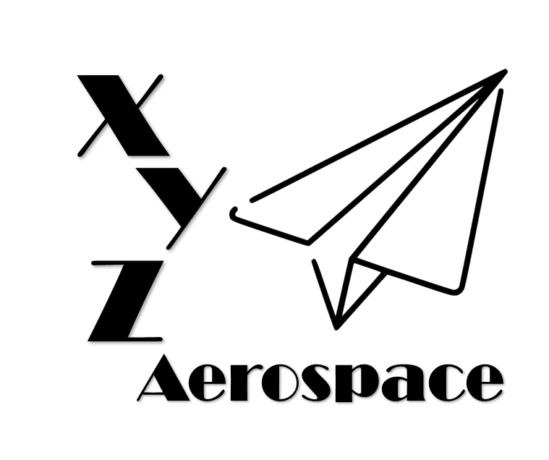

645 Colonel Glenn Blvd

Dayton, Ohio

DISCLAIMER: This document has been produced to support training and experimentation ONLY. It does not represent any system, real or planned. No United States Government resources were used to produce this document.

**THIS PAGE IS INTENTIONALLY BLANK**

Contents

1. Introduction 5

2. Flight Performance 5

1. Maximum 5

3. Control Communications 5

**THIS PAGE IS INTENTIONALLY BLANK**

1. Introduction
2. Transportability
   1. Test 1
      1. Setup Time

Fails, but I need to think about how to modify it

* + 1. Peculiar Handling Equipment

Fails, but need to describe it

* + 1. Mass Properties

Data shows that it passes, because it assumes that the configuration is only day or night…

1. Power
   1. Test 1
      1. Battery Life

Fails

* + 1. Shore Power

Fails

1. Weather Performance
   1. Test 1
      1. Resilient to Rain

Fails, think about what causes the failure